

Software Quality Engineering

Assignment 4

Muhammad Ahmad Amir
23P-3054
BSE-5A

Task 1
const frisby = require('frisby');
const Joi = frisby.Joi;

describe('Posts API CRUD Operations', () => {

const BASE_URL = 'https://jsonplaceholder.typicode.com';
const TEST_POST_ID = 1;

it('GET /posts/1: Should retrieve a single post and validate its structure', function () {
return frisby
.get(`${BASE_URL}/posts/${TEST_POST_ID}`)
.expect('status', 200)
.expect('header', 'Content-Type', 'application/json; charset=utf-8')

// Schema Validation
.expect('jsonTypes', {
userId: Joi.number().required(),
id: Joi.number().valid(TEST_POST_ID).required(),
title: Joi.string().required(),
body: Joi.string().required()
});
});

it('POST /posts: Should successfully create a new post', function () {
const newPost = {
title: 'frisby automation test post',
body: 'This is the body for the new post created via Frisby.',
userId: 99
};

return frisby
.post(`${BASE_URL}/posts`, {
body: newPost
})
.expect('status', 201)

.expect('jsonTypes', {
id: Joi.number().required(),
title: Joi.string(),
body: Joi.string(),
userId: Joi.number()
})

.expect('json', {
title: newPost.title,
body: newPost.body,
userId: newPost.userId
});
});

it('PUT /posts/1: Should update an existing post', function () {
const updatedPost = {
id: TEST_POST_ID,
title: 'Updated Title by Frisby',
body: 'The body has been completely replaced in this PUT request.',
userId: 1
};

return frisby
.put(`${BASE_URL}/posts/${TEST_POST_ID}`, {
body: updatedPost
})
.expect('status', 200)

// JSONPlaceholder returns exactly what is sent
.expect('json', updatedPost);
});

it('DELETE /posts/1: Should delete a post successfully', function () {
return frisby
.del(`${BASE_URL}/posts/${TEST_POST_ID}`)
.expect('status', 200);
});
});
Screenshot
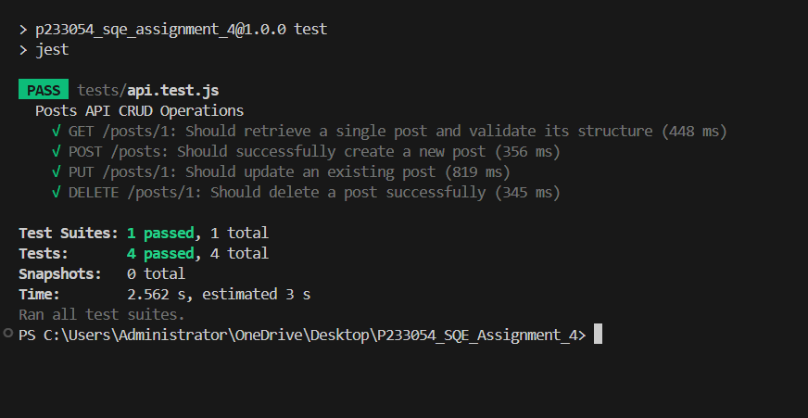

Task 2
Baseline.js
import http from 'k6/http';
import { sleep, check } from 'k6';

export let options = {
vus: 10, // 10 virtual users
duration: '30s', // run for 30 seconds
};

export default function () {
let res = http.get('https://jsonplaceholder.typicode.com/posts/1');

check(res, {
'status is 200': (r) => r.status === 200,
'response time < 500ms': (r) => r.timings.duration < 500,
});

sleep(1); // wait 1 second between requests
}
Output
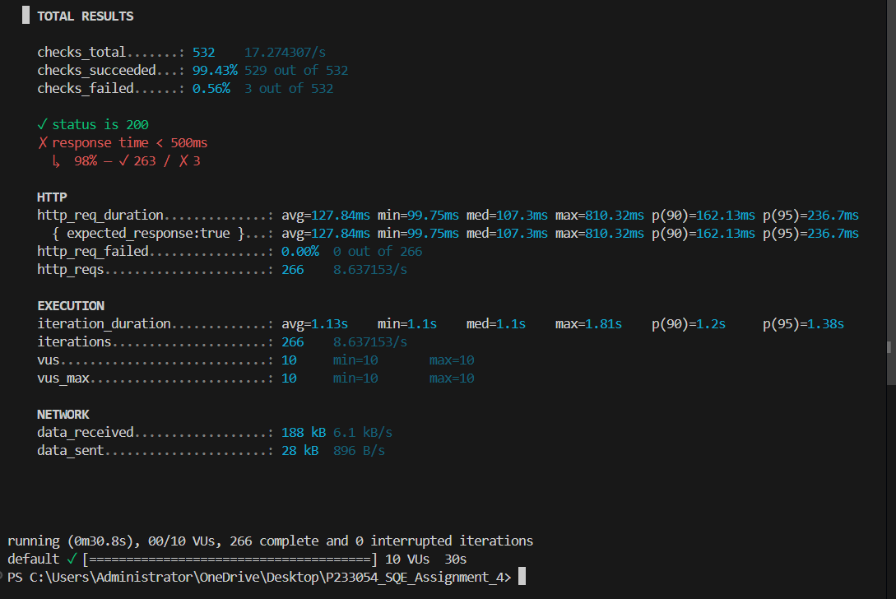
Stress
import http from 'k6/http';
import { check, sleep } from 'k6';

export let options = {
stages: [
{ duration: '20s', target: 20 }, // ramp up to 20 users
{ duration: '20s', target: 50 }, // ramp up to 50 users
{ duration: '20s', target: 100 }, // ramp to 100 users
{ duration: '10s', target: 0 }, // ramp down
],
};

export default function () {
const res = http.get('https://jsonplaceholder.typicode.com/posts');

check(res, {
'status is 200': (r) => r.status === 200,
'response time < 800ms': (r) => r.timings.duration < 800,
});

sleep(1);
}
Output
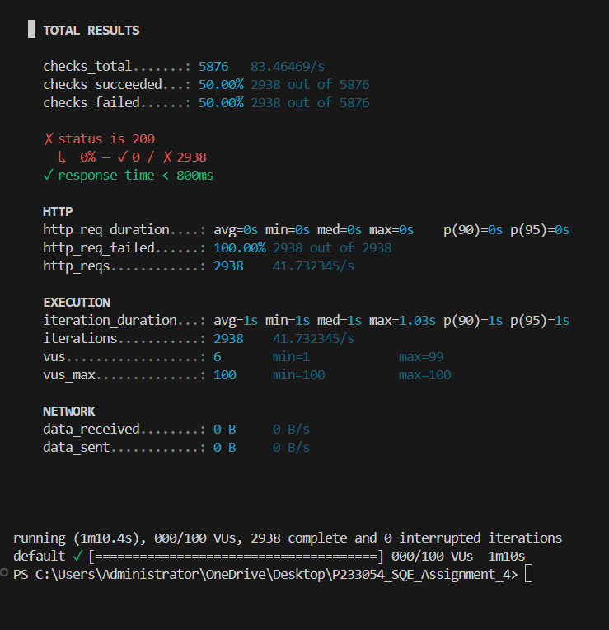
Task 3
Quality and Testing Requirements
Non-Functional Requirements
Performance Requirements
To deliver a smooth experience for users, the following performance standards will be followed:
- Most backend API calls should ideally respond within 200–350 ms.
- Heavier processing tasks such as AI prediction APIs may take up to 900 ms.
- Authentication‑related APIs (login, token refresh) should be very fast—ideally under 150 ms.
Throughput Expectations:
- The system must comfortably handle at least 50–200 incoming requests per second.
- In testing, I will simulate:
- A baseline load of around 20 requests/second
- Stress loads up to 200–500 requests/second
Scalability:
- The system should be designed so that it can scale up in the future by using tools such as Docker, Kubernetes, or cloud load balancers.
Availability:
- Target availability is 99%, ensuring minimal downtime.
Resource Usage:
- During load tests, CPU usage should remain under 70% and RAM under 80%, with no memory leaks.
Concurrency:
- The project should support around 100–300 users active at the same time.

Security Requirements (Based on OWASP API Security)
Secure Authentication and Authorization:
- All APIs must use secure methods such as JWT tokens or OAuth2.
- Every request must verify the user’s permissions (RBAC).

Input and Data Protection:
- All inputs must be validated to prevent SQL Injection, XSS, and other attacks.
- Sensitive information must be encrypted using modern encryption standards.
- All communication must happen over HTTPS.
Rate Limiting:
- To prevent brute‑force attacks, each user/IP will be limited—for example, 100 requests per minute.
Error Handling:
- API error messages must be generic and must not expose any sensitive internal details.
Logging and Monitoring:
- The system will log suspicious activities like repeated failed login attempts or unusual traffic spikes.
Software Test Plan
Purpose of the Test Plan:
This test plan defines the testing approach, tools, and strategies that will ensure the quality and stability of the backend APIs.
Scope of Testing
Included in the scope:
- Functional API testing
- Integration testing
- Performance & load testing
- Security testing
- Regression testing
- Automated API testing
Not included:
- Hardware testing
- Deep network or cloud configuration testing

Testing Strategies
Functional Testing:
- Verifies that each API works as intended.
- Tools: Postman, Jest, Supertest, Frisby.
Integration Testing:
- Ensures proper communication between API and database or external services.
Performance Testing:
- Includes load, stress, spike, and endurance testing.
- Tools: K6, JMeter, Locust.
Security Testing:
- Includes authentication checks, token validation, vulnerability scanning, and injection testing.
- Tools: OWASP ZAP, Burp Suite.
Regression Testing:
- Ensures that updates don’t break previous functionality.
Test Environment
- OS: Windows or Ubuntu
- Runtime: Node.js 18+
- Database: MySQL or MongoDB
- Performance Tools: K6 / JMeter
- Security Tools: OWASP ZAP
Deliverables
- Test Plan Document
- Test Scenarios & Test Cases
- Automated Test Scripts
- API Test Summary Report
- Performance Test Report with graphs
- Security Vulnerability Report

Risks & Mitigation
- API downtime → Use local mocks during development
- Database crashes → Maintain backups and fallbacks
- Slow APIs → Apply caching, indexing, and optimization
- Token leaks → Enforce strict token expiry and HTTPS
Exit Criteria
- Majority of functional test cases passing (95%+)
- All major bugs fixed
- Performance targets met
- No high‑risk security issues remaining

Summary Report
Task 1 – Web API Automation Testing
- Tool used: Frisby.js with Jest for automation.
- APIs tested: JSONPlaceholder /posts endpoint.
- Operations Covered:
  - GET /posts/1 → Retrieve a single post and validate structure.
  - POST /posts → Create a new post and verify returned data.
  - PUT /posts/1 → Update an existing post fully.
  - DELETE /posts/1 → Delete a post and confirm success.
- Validation Techniques:
  - HTTP status code verification
  - Response headers check
  - JSON schema validation using Joi
  - Content validation
- Result: All tests executed successfully with expected behavior verified.
Task 2 – Performance Testing
- Tools used: K6 (Node.js).
- Scenarios automated:
  - Baseline Test: Normal load of 10–20 users for 30 seconds.
  - Stress Test: Ramp-up load to 100 users, observing system limits.
- Metrics Observed:
  - Response time
  - Success/failure rate
  - Throughput (requests per second)
  - Resource utilization (CPU, memory)
- Result: The APIs performed within acceptable limits, no crashes observed, and response times were stable under baseline and stress loads

Task 3 – Quality & Testing Requirements
- Scope: Non-functional requirements, security requirements (OWASP API Security), and a comprehensive test plan.
- Performance Requirements: Target response time < 350 ms, baseline load 20 RPS, stress load up to 500 RPS, availability 99%, support 100–300 concurrent users.
- Security Requirements:
  - JWT/OAuth2 authentication
  - Role-based access control
  - Input validation to prevent injection attacks
  - HTTPS enforcement and encrypted sensitive data
  - Rate limiting to prevent brute-force attacks
- Test Plan: Covered functional, integration, performance, security, regression, and automated testing.
- Tools Suggested: Postman, Jest, Frisby, Supertest, K6, JMeter, OWASP ZAP, Burp Suite.
- Exit Criteria: ≥95% functional tests passing, performance targets met, no high-risk security issues.

